**Live Keyboard and Mouse Input**

https://www.youtube.com/watch?v=76i2TCyx8Wo&list=PLRtjMdoYXLf776y4K432eL_qPw4na_py3&index=10

#include "stdafx.h"

#include "SFML/Graphics.hpp"

#include <iostream>

#include <windows.h>

int main()

{

sf::RenderWindow window (sf::VideoMode(600, 600), "SFML works!");

while (window.isOpen()) {

sf::Event event;

while (window.pollEvent(event)) {

switch (event.type) {

case sf::Event::Closed:

window.close();

break;

}

}

if (sf::Keyboard::isKeyPressed(sf::Keyboard::Space)) {

std::cout << "In process of JUMPING" << std::endl;

Sleep(10);

}

if (sf::Mouse::isButtonPressed(sf::Mouse::Left)) {

std::cout << "in process of FIRING AN AUTOMATIC GUN!" << std::endl;

Sleep(10);

}

window.clear();

window.display();

}

}

**Result**

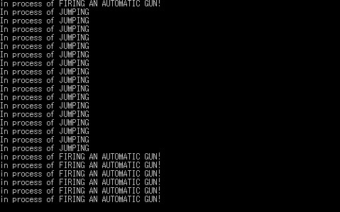

**Important notes:**

* Sleep() function can be used from the library <windows.h>